# Enterprise Software Platform Project Report

## Installing Docker on Mac

This section describes the procedure to install docker toolbox on Mac.



Figure - DOCKER HOST ON MAC

In an OS X installation, the docker daemon is running inside a Linux VM called default. The default is a lightweight Linux VM made specifically to run the Docker daemon on Mac OS X. The VM runs completely from RAM, is a small ~24MB download, and boots in approximately 5s.

In OS X, the Docker host address is the address of the Linux VM. When you start the VM with docker-machine it is assigned an IP address. When you start a container, the ports on a container map to ports on the VM.

1. Go to the [Docker Toolbox](https://www.docker.com/toolbox) page.
2. Click the installer link to download.
3. Install Docker Toolbox by double-clicking the package or by right-clicking and choosing “Open” from the pop-up menu.



1. Press “Continue” to install the toolbox.



1. By default, the standard Docker Toolbox installation:
   1. installs binaries for the Docker tools in /usr/local/bin
   2. makes these binaries available to all users
   3. installs VirtualBox; or updates any existing installation
2. Once the installation completes, press “Close” to exit

Once the docker toolbox is installed, we create a docker VM.

1. Create a new Docker VM.

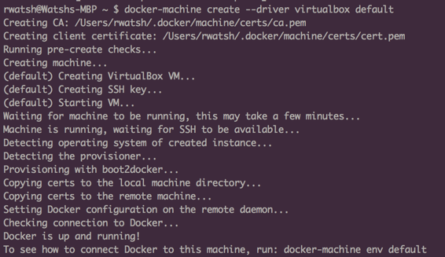

1. This creates a new default VM in VirtualBox.
2. The command also creates a machine configuration in the~/.docker/machine/machines/default directory. You only need to run the create command once. Then, you can use docker-machine to start, stop, query, and otherwise manage the VM from the command line.



1. Get the environment commands for your new VM.

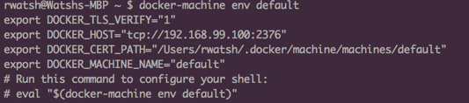

1. Connect your shell to the default machine.



1. Run the hello-world container to verify your setup.

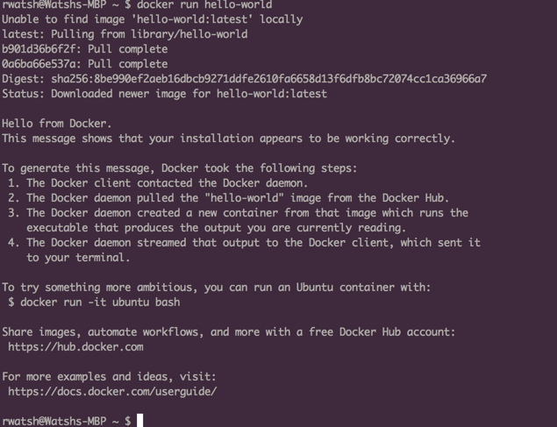

“Quote”

Want to insert a picture from your files or add a shape, text box, or table? You got it! On the Insert tab of the ribbon, just tap the option you need.

Find even more easy-to-use tools on the Insert tab, such as to add a hyperlink, insert a comment, or add automatic page numbering.

## Heading 2

* Use styles to easily format your Word documents in no time. For example, this text uses the List Bullet style.
* On the Home tab of the ribbon, check out Styles to apply the formatting you want with just a tap.

|  |  |  |
| --- | --- | --- |
|  | Column Heading | Column Heading |
| Row Heading | Text | 123.45 |
| Row Heading | Text | 123.45 |
|  |  |  |